Update the servo:

  - Connect the servo to the DPC-CAN device as well as servo power. Connect the DPC-CAN device via USB to your Windows computer. Note the COM port associated with the DPC-CAN.
  - Open the DPC-CAN Update tool, select the appropriate COM port, and press [Open]. You should see the text box populate with the DPC-CAN-V34 version as noted below:
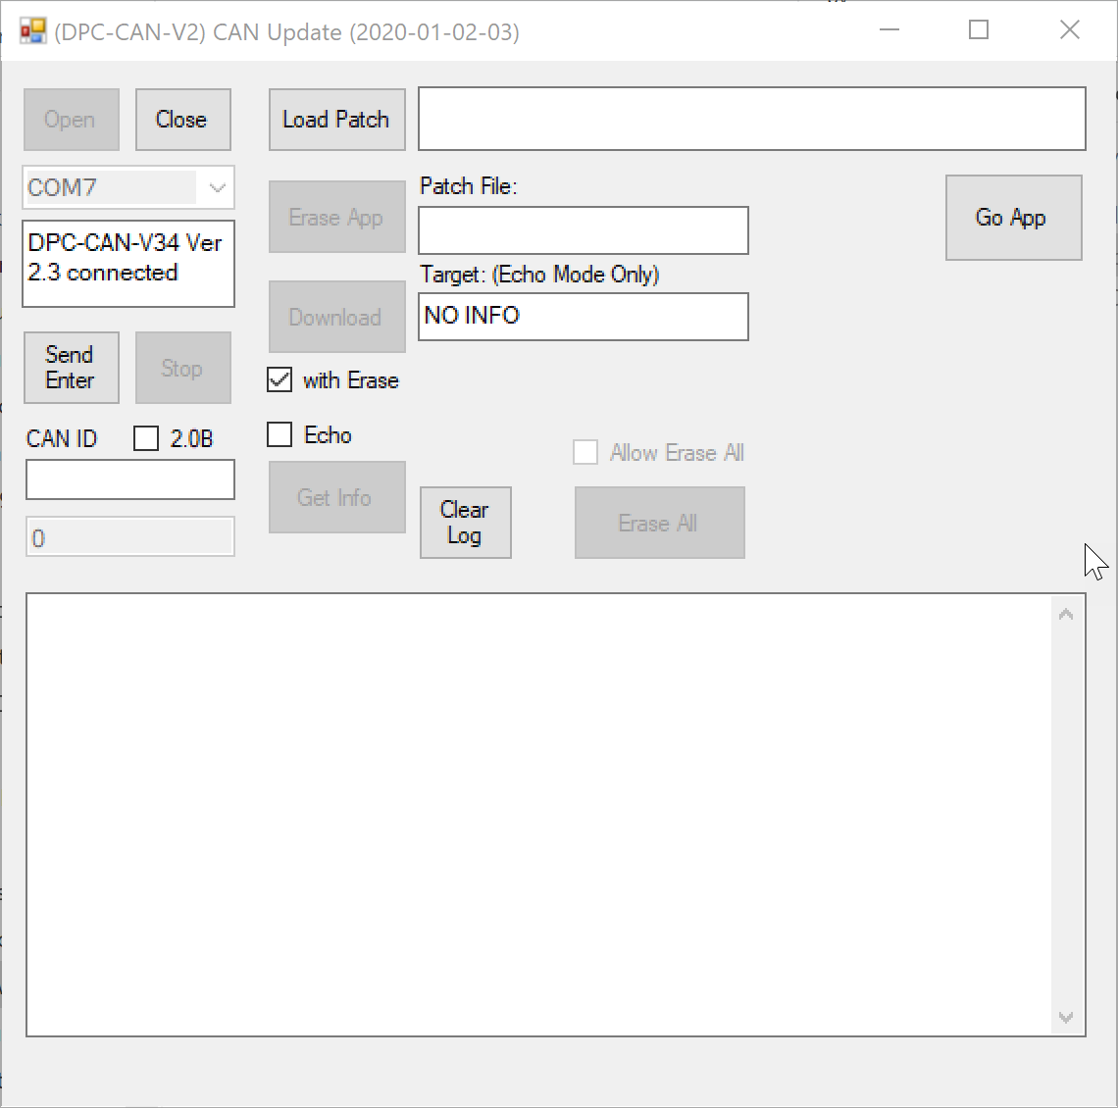

  - The servo must now be placed in to bootloader mode. To do this, press [Send Enter] and then tick the “Echo” checkbox. Now, remove your battery power from the DPC Can, wait 2-3 seconds, and re-add it and quickly press [Get Info]. If the “Target: (Echo Mode Only)” text field does not update to a valid firmware version, you have not gotten the servo in to bootloader mode and must repeat this step.
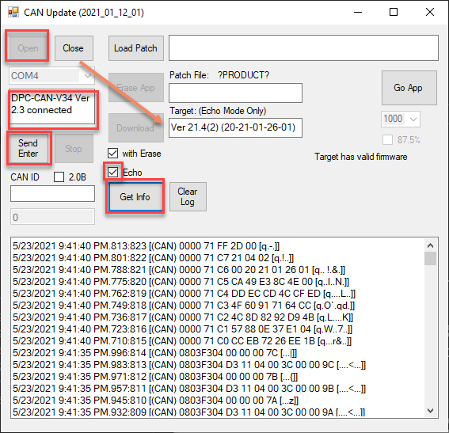
  - Press [Load Patch] and browse to the update file: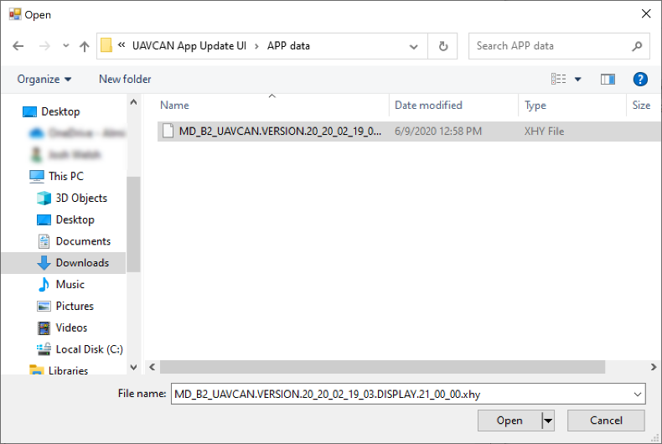
Click [Open] once you have the file selected.

  - With the patch selected, you can now press [Erase App]
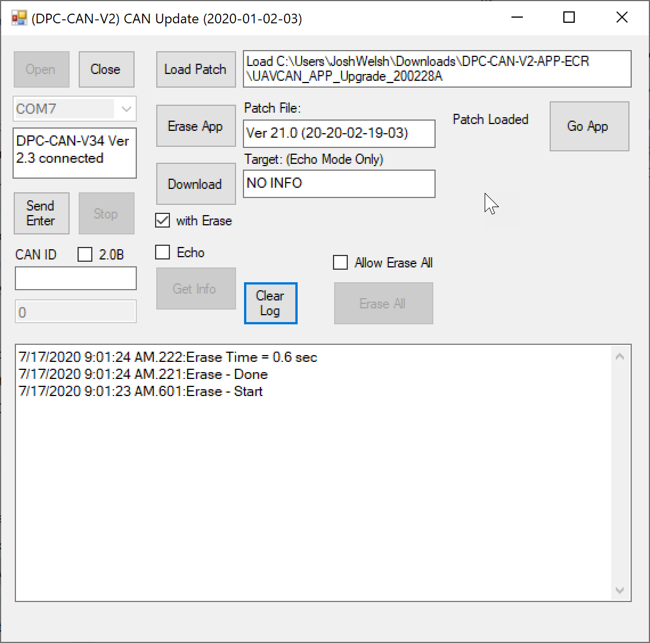
  - With the original firmware erased, you now click the [Download] button to begin the downloading of the firmware from your computer to the Servo
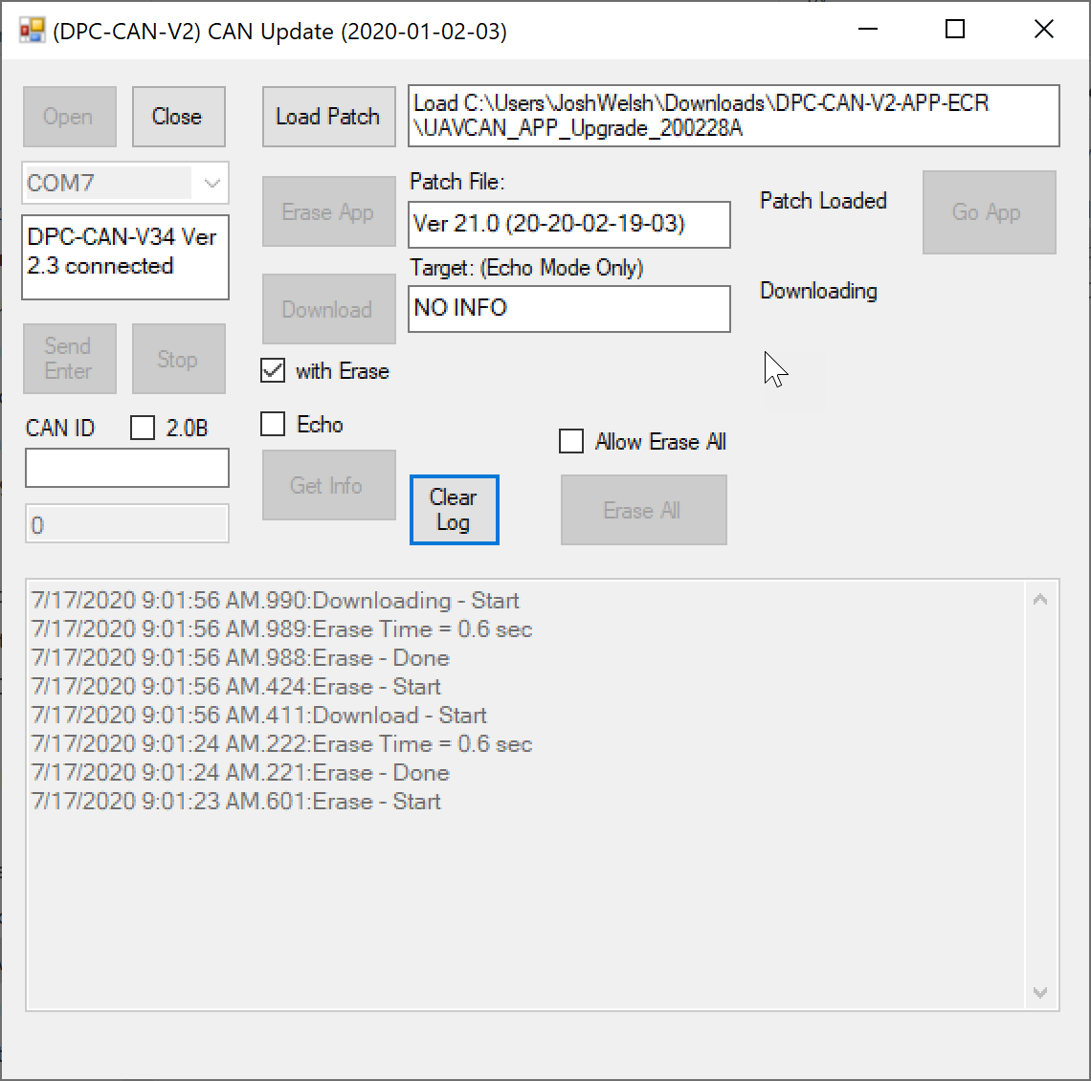

  - With a successful firmware install, the only thing remaining now is to press the [Go App] button. This will bring the servo out of Bootloader mode and verify the servo is ready for operation.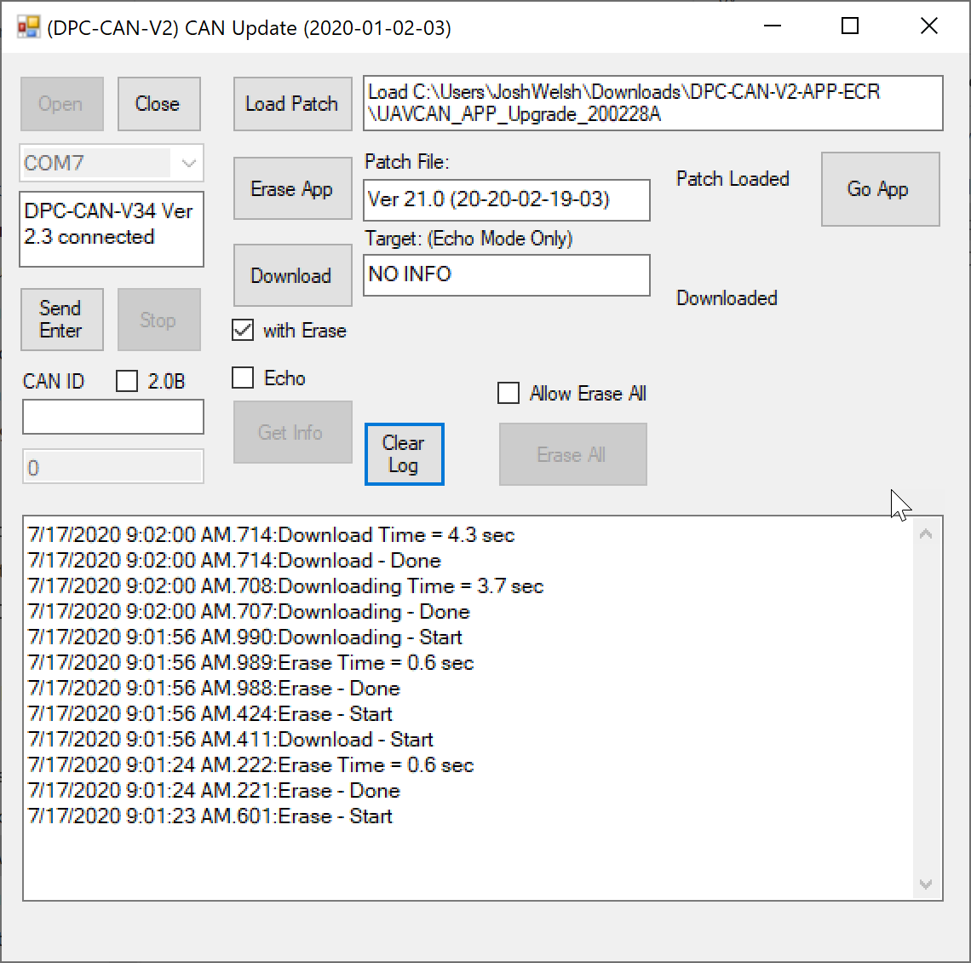
  - With the [Go App] button pressed, data will begin streaming. The firmware is now operational on the servo. Congrats!
